On Target Lab Names ________________________________________________________________
Modified from Jim Askew @ Howe Public Schools, Oklahoma, http://www.howe.k12.ok.us/~jimaskew/ps/pslab23a.htm 14 Sep 2004.

v_{x} = d_{x1}/t  d_{y} = ½ gt_{y}² or t_{y} = (2d_{y}/g)^{½}  d_{x2} = v_{x}t_{y} | 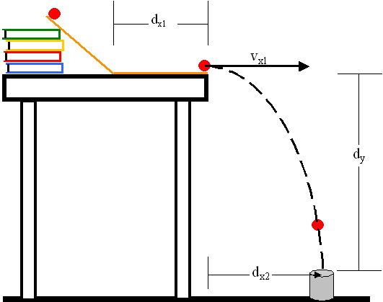
- Set up the apparatus shown here at your table.
- Roll the marble down the ramp and measure time on the horizontal portion of the ramp. Use the fist equation to determine v_{x} and t.

_______
_______
_______
_______
_______
_______
_______
_______
_______
_______
_______
_______

- Show your calculations here

- Use the second equation to calculate t. Measure d_{y}, the vertical distance (meters) from the top of the table to the floor.

d_{y} = ________________ m

- Show that calculation here: X

X
X
- Use v_{x} and t to calculate d_{x2}
- Show your calculations here.

- Place your cup at the calculated location, toll the marble down the ramp one time and report the results in the lab conclusion below.

