Clouds 1
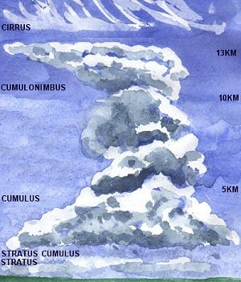
1 – Soil (9)
2 – Glaciers (6)
3 – Lakes (3)
4 – Clouds (1)
5 – Ocean (2)
6 – Ocean (2)

Ocean 2
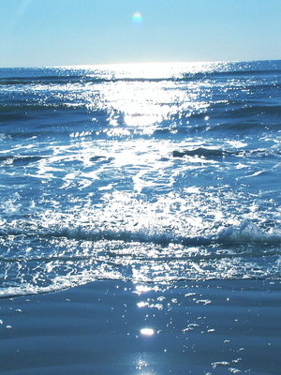
1 – Clouds (1)
2 – Ocean (2)
3 – Ocean (2)
4 – Clouds (1)
5 – Ocean (2)
6 – Ocean (2)

Lakes 3
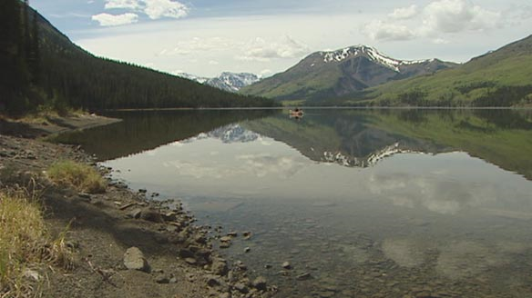
1 – Lakes (3)
2 – Groundwater (4)
3 – Animals (5)
4 – Lakes (3)
5 – Rivers (7)
6 – Clouds (1)
Groundwater 4
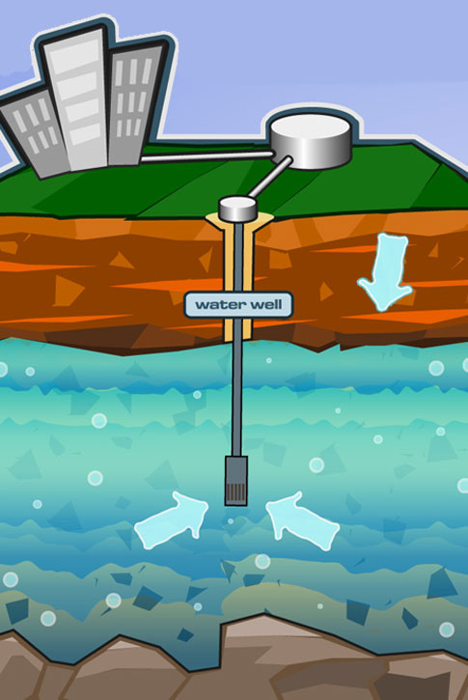
1 – Groundwater (4)
2 – Lakes (3)
3 – Groundwater (4)
4 – Lakes (3)
5 – Groundwater (4)
6 – Rivers (7)
Animals 5
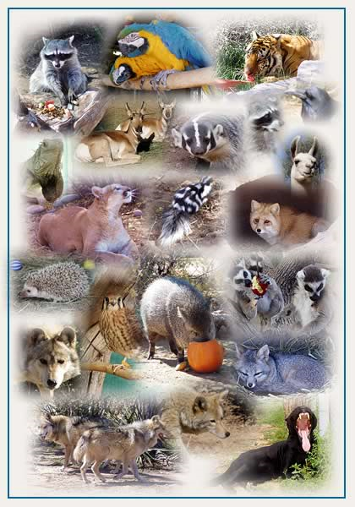
1 – Soil (9)
2 – Clouds (1)
3 – Animals (5)
4 – Clouds (1)
5 – Soil (9)
6 – Clouds (1)
Glaciers 6
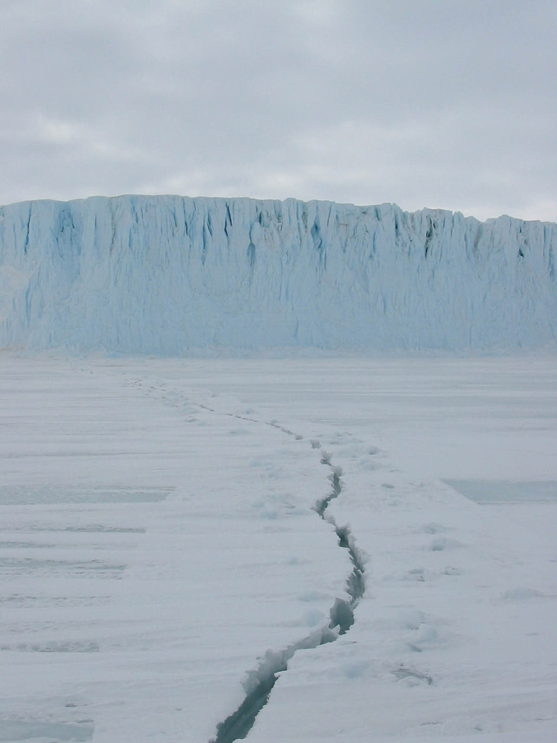
1 – Glaciers (6)
2 – Rivers (7)
3 – Glaciers (6)
4 – Clouds (1)
5 – Glaciers (6)
6 – Groundwater (4)
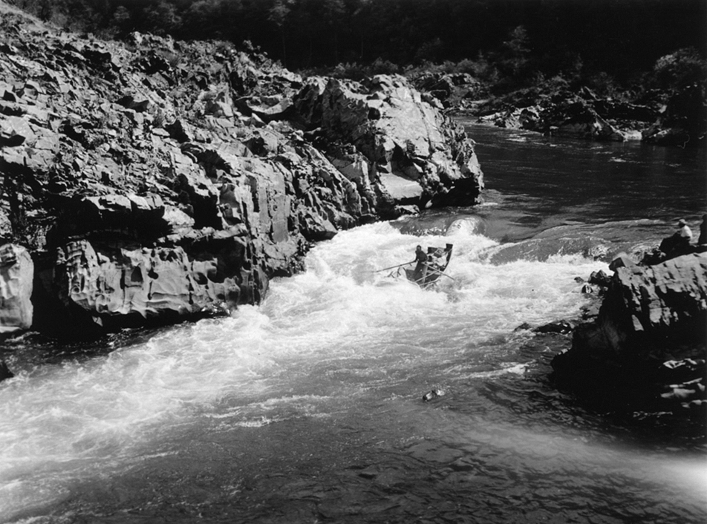
Rivers 7
1 – Lakes (3)
2 – Groundwater (4)
3 – Ocean (2)
4 – Animals (5)
5 – Clouds (1)
6 – Rivers (7)
Plants 8
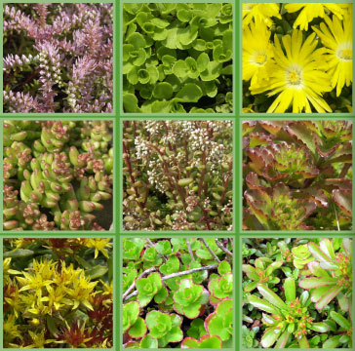
1 – Clouds (1)
2 – Animals (5)
3 – Clouds (1)
4 – Plants (8)
5 – Clouds (1)
6 – Plants (8)
Soil 9
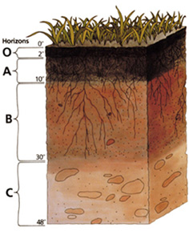
1 – Groundwater (4)
2 – Clouds (1)
3 – Soil (9)
4 – Groundwater (4)
5 – Rivers (7)
6 – Plants (8)
Student Handout: H2-Flow Name:___________________________
Procedure

1. You are each playing the role of a molecule of water for this simulation. Your teacher will start by assigning you to one of the nine stations around the room and giving you a piece of string to place a bead from each station you visit. This 3 x 5 notecard will record your movements through the hydrological cycle.

2. When you are at the front of the line for your station, mark a line on your card and then you will roll the dice. Each die has an option for movement for the molecule, including staying in place. You should follow the direction from the result of the roll, and go to the back of the line for the corresponding station.

3. If you move to another station, consider the mechanism for movement. You MUST identify if you moved by evaporation, transpiration, condensation, precipitation, or some other mechanism. You should also be able to identify the state of water at each station and in each movement (solid, liquid, gas).

4. Remember that for each station, even if you stay at the station, you should draw a new line.

5. Continue to cycle through the stations until your teacher instructs you to return to your seats.

Analysis
On a separate sheet of paper please complete the following:

1. What forms did your molecule spend the most time in? Why?

2. What station would it have been impossible to move directly between? Why?

3. For what percent of your simulation did you spend time as freshwater available for human consumption? What can you deduce from this about the amount of available freshwater on Earth?

4. How can a growing human population affect the hydrologic cycle

Location | Color | Movement Method to Next Location
Location | Color | Movement Method to Next Location
Location | Color | Movement Method to Next Location

